**HTML & Website Design**

**Project Group Process Workbook**

**2014**



**Assignment Assessment Overview**

**Each Group should complete the following in relation to the Group work process and submit as part of your project.**

|  |  |
| --- | --- |
| **Group Report and Logbook** | **20%** |
| **Progress Report** – There should be at least 2 progress-report entries posted by each Group | 3% |
| Template 1 – Roles & Responsibilities | See below |
| Template 2 – Understanding the Problem | 1% |
| Template 3 – Exploring Ideas | 2% |
| Template 4 – Group Action Plan | 2% |
| Template 5 – Individual Action Plan | 3% |
| Template 6 – Individual Reflection | 3% |
| Template 7 – Bibliography | 1% |
| Template 8 – Peer Review | 5% |

## Template 1 Roles & Responsibilities

**Roles & Responsabilities**



In order for the group to work effectively it is necessary for members to take responsibility for specific tasks. Assign a group member to each of the roles. If a group member is not performing their role this must be managed within the group. If this cannot be addressed within the group please contact one of your Project lecturers as soon as possible.

|  |  |  |
| --- | --- | --- |
| Role | Responsibility | Team Member |
| Chairperson | Ensures each member remains on task and ensures that all members have a voice | Dean Moore |
| Time Keeper | Ensures that all tasks are completed on schedule and that meeting time is used appropriately | Jovellyn Quiapos Dean Moore |
| Record Keeper | Ensures that all ideas are documented and templates are completed | Jovellyn Quiapos |

## Template 2 Understanding the Problem



**INTERPRET THE PROBLEM**

Using the headings below, discuss the details of the assignment amongst group members and fill out the template.

|  |
| --- |
| 1. Define the problem. What are you being asked to do? Have you finalised on your subject area for your website?   Our problem is creating a holiday package website for families and/or business trips. We Are asked to create a simple booking site that is easy on the eye and has intelligent links to credit cards/paypal for the packages. |
| 1. List the different XHTML concepts & Web design considerations that will need to be understood in order to complete this assignment.  * The layout * Must be clean and un-cluttered * Easy on the eyes * Colours has |
| 1. What approach will be taken to implement the website e.g. CSS/tables? Explain your reasons for decisions taken.   The majority of the site will be consisting CSS with a small part of it being with tables due to the need of the website to be clean and uncluttered. |
| 1. What has been your Group’s strategy for validating your code? How have you approached this?   We are going to validate our code from the w3s validating site and also the lecturer and the higher year students. We approached this during class time as we ask the lecturer and the higher year students to look over our coding. After class we would use the validating website to look over our code and check for any mistakes. |

## Understanding the Problem



**Project requirements**

List the requirements that you have for your website

|  |
| --- |
| 1. What is the overall goal of your website?   Our overall goal is to make the website easy to use and affordable options for students, families and business trips. |
| 1. What are the functional requirements for your site? What will the site **do**?   There is going to be google maps, google translate, site visitors, video, gallery, and intelligent links. The site will guide the user to their preferred holiday package and ask them to pay for it. |
| 1. What are the non-functional requirements of your site? Do you have a preference for the look and feel of the site?   We choose the site to be a simple colour and easy on the eyes. While having strong colour on important areas of the site. |
| 1. What other requirements do you want to achieve in your site?   We also hope to cater for the elderly and the disabled through the options in our packages. |

## Template 3 Exploring Ideas

## Exploring ideas – What will the user interface look like?

Discuss possible designs for your website. Once the group decides on a design use Microsoft Word or a Balsamique Mockup to demonstrate the chosen design and layout of website.

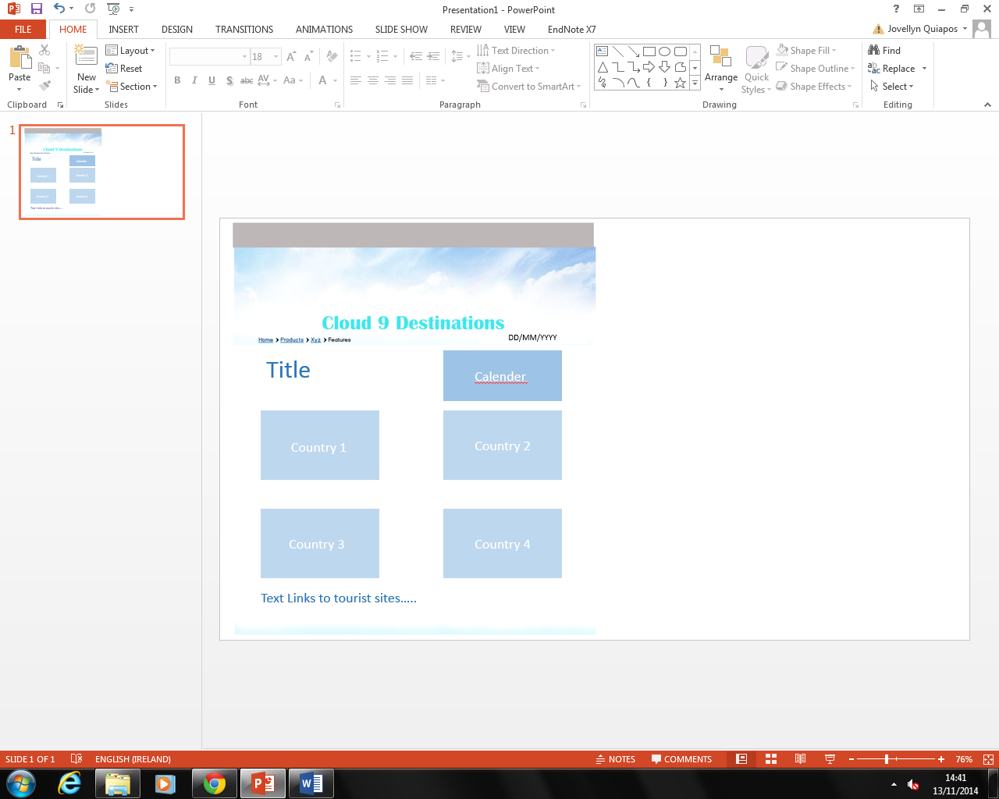

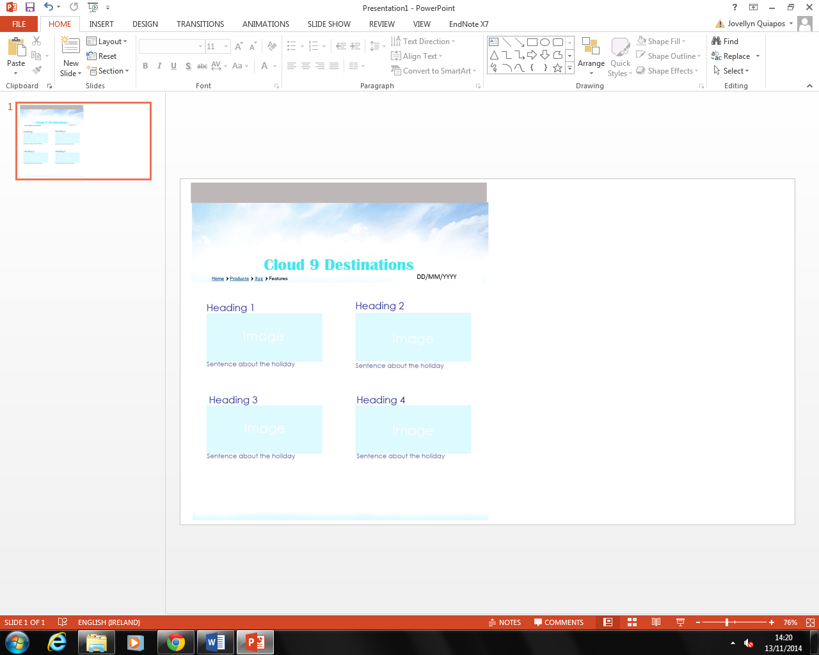

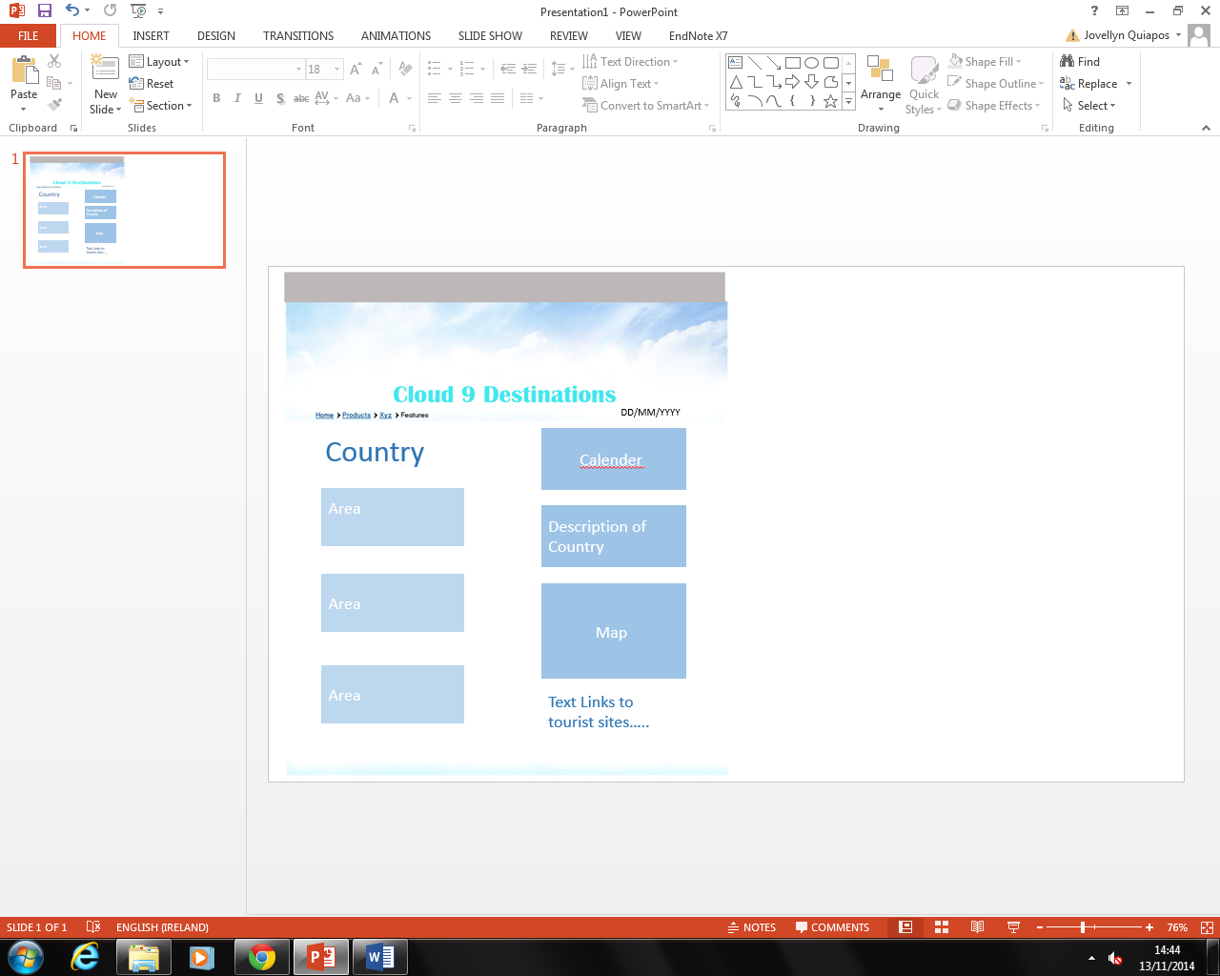

## Exploring Ideas

## Exploring ideas – What will the user interface look like?

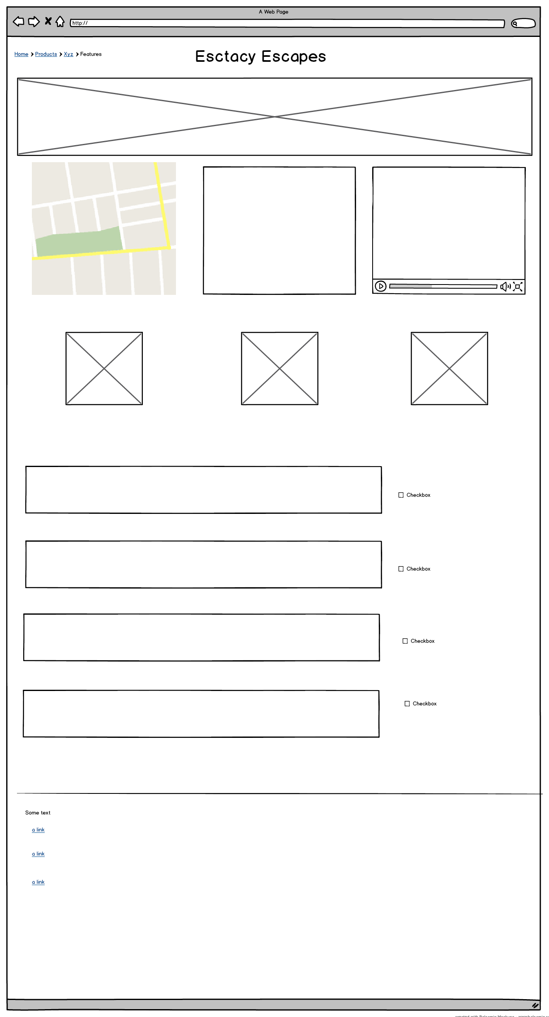 **Include Wireframes here**

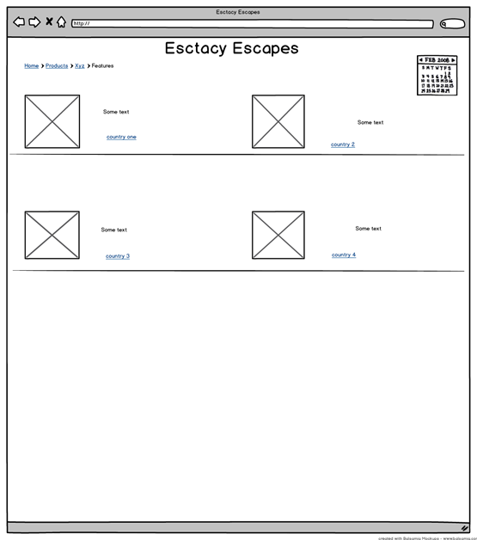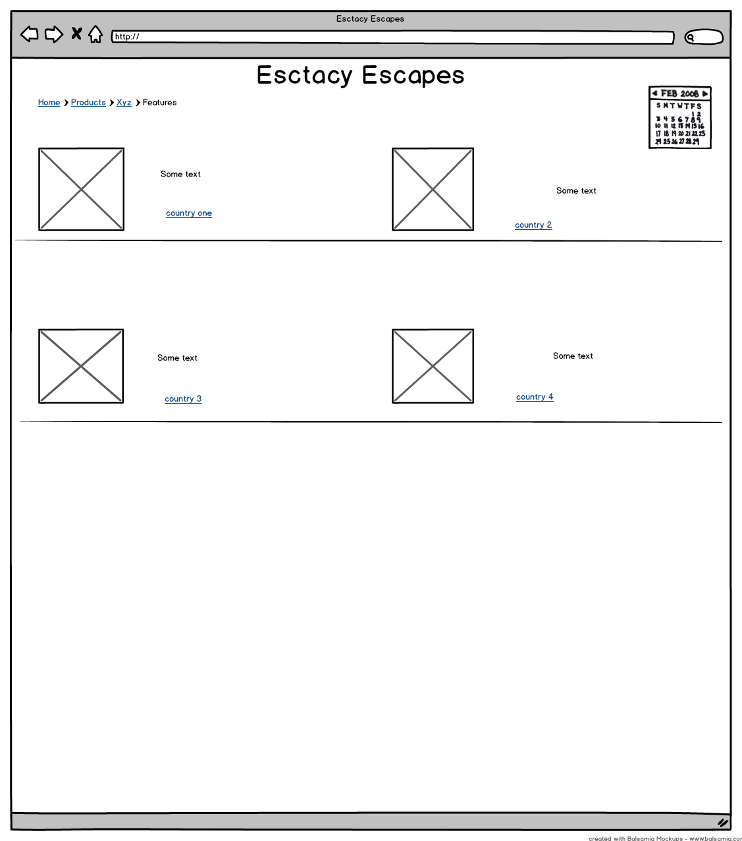

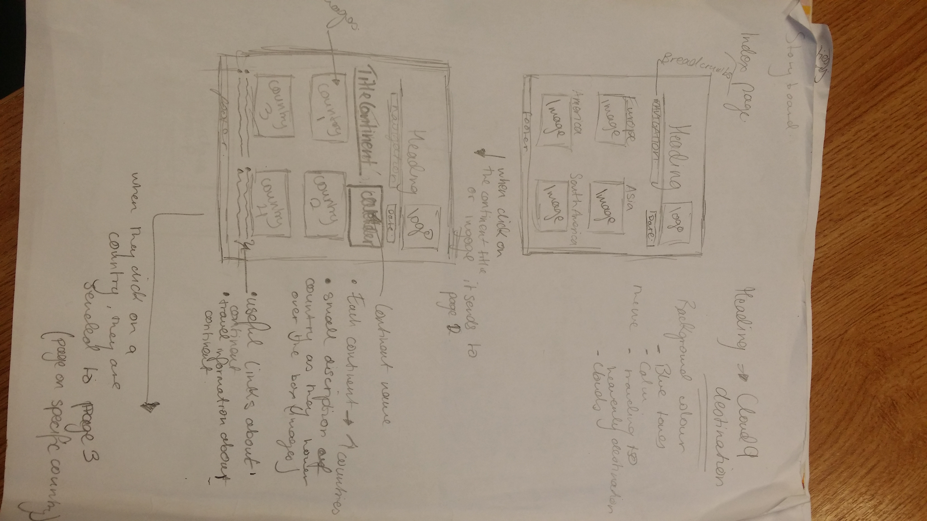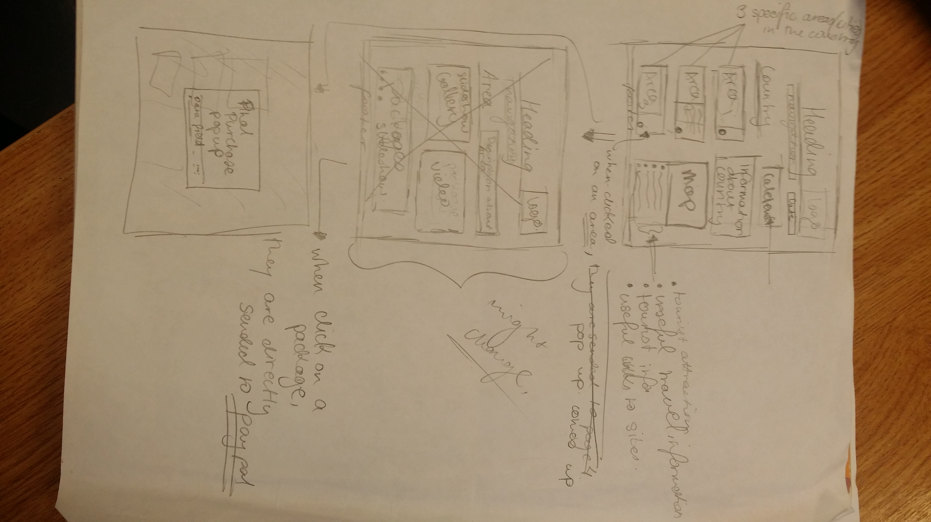

**Template 4 Group Action Plan**



**Group Action Plan**

List the tasks your group needs to complete

Assign tasks to each group member and agree on appropriate timelines

**Action Plan:**

|  |  |  |  |
| --- | --- | --- | --- |
| No. | Action | Responsibility | Completed |
| 1 | Colour decisions | Jovellyn | Done |
| 2 | Amount of website pages. | Dean | Done |
| 3 | Design of website | Jovellyn | Done |
| 4 | HTML | Dean | Done |
| 5 | Project workbook | Jovellyn | Done |
| 6 | Javascript | Dean | Done |
| 7 | Research for the first 6 pages. | Jovellyn | Done |
| 8 | Research for the last 6 pages | Dean | Done |
| 9 | CSS | Jovellyn | Done |
| 10 | Validation | Dean | Done |
|  | | | |

**Template 5 Individual Action Plan**

**Group member 1 should fill in this page**

**Individual Action Plan**

Based on the task(s) assigned to you – record and synopsise your findings under the headings below.

Student Details: Student Name: Dean Moore. Student Number: x14576363

1. What task(s) have you been assigned?

* Amount of website pages.
* HTML
* Javascript
* Research for the last 6 pages
* Validation

1. What information did you find out from your research?

The main products of most holiday pages would be that they would have calendars, the date in the top part of the screen, they would also have a list if fields to complete before you could move on to payment and confirmation

1. Explain how this information may be useful in the development of the website.

This means that the site we are making will be less cluttered and filled with useless information and over all look unprofessional

1. What are you going to feedback to the group?

The items we are going to need will be the calendars and the date as well as the data fields for confirmation and payment

1. Reference the information you have found.

<http://www.sunway.ie/> <http://www.sunholidays.ie/?gclid=CJTvvcfs98ECFaR02wodujUATA>

<http://www.budgettravel.ie/> <http://www.thomascook.ie/holidays>

* **Individual Action Plan**

**Group Member 2 should fill in this page**

**Individual Action Plan**

Based on the task(s) assigned to you – record and synopsise your findings under the headings below.

Student Details: Student Name: Jovellyn Quiapos. Student Number: x14331851

1. What task(s) have you been assigned?

* Colour decisions
* Design of website
* Project workbook
* Research for the first 6 pages.
* CSS

1. What information did you find out from your research?

From researching sites, I looked at how the Travel sites are laid out the pictures , the links and how they used to colours to keep their website looking simple and easy for the customers eyes. I also look at the fonts and how their logo goes with the colour scheme of the holiday website.

1. Explain how this information may be useful in the development of the website.

This is helpful as it gave me ideas on how to keep the website looking simple and how to attract the person to go and look into to our website.

1. What are you going to feedback to the group?
2. Reference the information you have found.

<http://www.sunway.ie/> <http://www.sunholidays.ie/?gclid=CJTvvcfs98ECFaR02wodujUATA>

<http://www.budgettravel.ie/> <http://www.thomascook.ie/holidays>

Template 6 Reflection

**Group Member 1 should fill in this page**

**REFLECTION**

It is important for the group to reflect on how they arrived at the solution and the solution itself and to identify what could be improved on next time. (Students should complete about 500 words reflection)

Student Details: Student Name: Dean Moore. Student Number: x14576363.

1. Overall what has the experience been like working as part of a project team?

From working part of this project team, the experience was very good. We both had good communications with each other, so we got things done well despite both of us living very far from each other. It was hard to have meetings together as we both live too are but despite that we tried to find any spare time within the week during our time in college and do some of our work. We had no problem when it came to talking our ideas. We would go over our ideas every time to just remind ourselves what we are doing and how we are going to do it.

1. What have been the most positive parts?

The positive parts would definitely be when we get our task done and out of the way. When it came to researching it was very good. It was very easy to understand our main task and design our own website. When we communicate is also another positive thing as we got our work done without any hassle and mistakes.

1. What could be improved on next time?

One thing we could improve more on is having our files more in order and less cluttered. That way it would be easy for both of us to understand when we get to put our task together. We both name our files differently so maybe we should keep the files the same. This way it won’t be confusing to both of us. Apart from those few things everything else is going smoothly.

## Template 6 Reflection

**Group Member 2 should fill in this page**

**REFLECTION**

It is important for the group to reflect on how they arrived at the solution and the solution itself and to identify what could be improved on next time. (Students should complete about 500 words reflection)

Student Details: Student Name: Jovellyn Quiapos. Student Number: x14331851

1. Overall what has the experience been like working as part of a project team?

The experience being part of this project team was amazing. We both learned a lot informations. Our communication skills were improved from all the communications we had. The meeting went smoothly and we understood what our ideas were and compromised it to create our website.

1. What have been the most positive parts?

The most positive parts of being part of the team was how we understood each other and how we frequently communicated with each other. The processed our website went smoothly and no misunderstanding were made. I Learned a lot on how to use margins, paddings and floats as I had difficulties with them before but not anymore.

1. What could be improved on next time?

Improvements that could be done next time is to look over each of our more frequently. To keep our files more cleaner and less cluttered. Also we should ask more on our customer’s aspects and see what we could have added more and take out some that might not be useful. I need to name my files correctly as I kept misspelling the file names and when I needed to direct the link path it wouldn’t work as I keep forgetting to rename the files.

## Template 7 Bibliography

**Referencing**

You must reference any books, articles, or web pages which you used to create your web pages. This might include content for your site or resources on how to use a piece of JavaScript code. You must use the **Harvard Referencing Style**. There are resources on moodle to help you with this style.

* <http://www.sunway.ie/>
* <http://www.sunholidays.ie/?gclid=CJTvvcfs98ECFaR02wodujUATA>
* <http://www.budgettravel.ie/>
* <http://www.thomascook.ie/holidays>
* <http://stackoverflow.com/>
* <http://www.w3schools.com/cssref/default.asp>
* <http://www.w3schools.com/html/default.asp>
* <http://paletton.com/>
* <http://www.freeimages.com/>
* <http://pixabay.com/>
* <http://www.dafont.com/>
* <http://www.google.com/fonts>

## Template 8 Peer Review

**PEER REVIEW**

When all group members contribute equally it makes sense for everyone to get the same result. However, if group members do not contribute evenly it is only fair that each group member receives the mark that truly reflects their contribution.

Each group member can earn a maximum of 10 marks for their contribution. Group members who made little or no contribution will receive fewer marks. The group must collectively rate each member’s contribution in the grid below by writing the member’s name in the box the group feels is most appropriate.

|  |  |  |  |
| --- | --- | --- | --- |
| **Main Contributor(s)**  **3D smiley 1**  **10 marks** | **Secondary Contributor(s)**  3D smiley 5  **7 marks** | **Minimal Contribution**  3D smiley 3  **3 marks** | **No Contribution**  [Picture]  **0 marks in Assignment** |
| Dean Moore  Jovellyn Quiapos |  |  |  |

I Jovellyn Quiapos agree with the marks that have been awarded for my contribution to the assignment.

I Dean Moore agree with the marks that have been awarded for my contribution to the assignment.